

System Maintenance and Technical Document (SMTD)
Machine Optimizer Input Data Pre-process
Version 1.0

<CLIENT LOGO>

Document Details
Prepared by/Date | Reviewed by/Date | Approved by/Date
Neil Sibug/ 01 Mar. 16
Revision History
Version | Date of Revision | Description of Change | Reason for Change | Affected Sections | Approved By
Draft
Affected Groups

1. Scope and Purpose 4
2. Application Overview 4
3. Business Processes 4
4. Application Access Procedure 4
5. Initial Status of the Application under Maintenance 4
5.1. Modules/Interfaces/Data structures 4
5.2. Documents 4
5.3. Standards and Guidelines 4
6. Application Environment 5
7. Affected Systems/Applications 5
8. User Interfaces 5
9. Application Design 5
9.1. Relation to External Systems 5
9.2. System / Sub-system Architecture 5
9.3. Inter-module Relationships 5
9.4. Application Modules 5
9.5. Database Details 6
10. Global Data Structures and Shared Data Functions 6
11. Critical Functions 6
11.1. Testing Strategies 6
11.2. Test Data 6
12. Reusable components 6
13. Limitations 6
14. References 6
15. Application History 7
15.1. Typical Problems 7
15.2. Release History 7
17. Learning 7

Terminology and Acronyms
List all the acronyms, abbreviations and terminologies used in the document
Terminology/ Acronym | Definition
MSOPT | Machine Optimizer
Wrapper Script | Is the automated process to prepare input data or generate another report from the output data
MSOPT_DB | MySQL Optimizer database

Scope and Purpose
This document is intended to capture the information of the application as acquired during the training and parallel perform phases. This is an evolving document and will be updated through the training and parallel perform phases. The sections in this document indicate the type of information that would be typically required to carry out the support/development/test activities during the steady state. The scope of this document is to point to the relevant documents available with <CLIENT> that would be used by Wipro to support the steady state activities. In cases where there are no documents pertaining to the information required in the section, the Wipro engineers will include a brief description based on their learning.

Application Overview
The Scope of the application should include the application overview, the list of modules, submodules, interfaces and related data structures that will be maintained. Also mention issues/items which are not going to be addressed/supported and assumptions made, if any. A Condensed version of the application scope will be provided here with reference to the relevant sections of this AID for more details. In case of very large applications where it is difficult to list down all the modules, a guideline to find out which modules are included in the application should be provided (for example modules with certain naming convention / acronym)

MSOPT

Input Data
Wrapper Script
(Pre-process)

Input data
(Processed)

MSOPT Pre-process script is an automated external process for downloading and preparing the input data from a specific data repository. The raw data are downloaded from the repository and then it will be imported in the MSOPT_DB, after that the wrapper script will be triggered and process the data from the database. The output of the wrapper script is the processed input data in addition backup file are created during this process. Finally after pre-processing of all input data it will then be process into the Machine Optimizer.

Business Processes
Briefly describe each business process supported by the application including the specific information on how the application supports that process.

Automated Task Schedule

Update TWSTATUS data

Download RTD Flat File

Download Input data

Pre-process wrapper script Input data

To prepare the Input data, there are several steps to be process within the Wrapper script; first is to update TWSTATUS data every hour. Then download some flat data file from the RTD, including the following (clatTester_StationStatus, TEST_NEXTLOTINFO, ATTSSTESTSPEC and TWSTATUS), from these set of files it will generate the SMSDW data. Next is to download the Input data from the network repository, all the critical data will then be transferred to the local Clark machine. Last but not the least is to process the pre-process script to generate a new set of input data from the original data.

Application Access Procedure
Describe the login procedure to access the application code, its configuration information, installation procedure and related systems that need to be supported. Details on steps to execute the application in development environment should also be mentioned here.

MSOPT Wrapper script
In accessing the wrapper script automated task schedule follow this steps.
- Go to Start>All Programs>RealVNC>VNC Viewer\

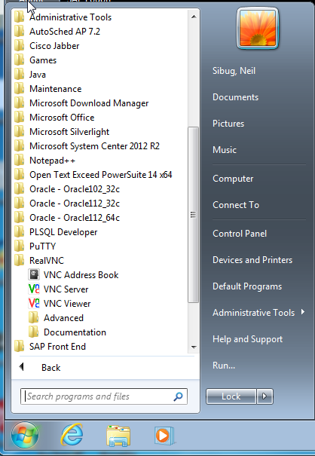

- Connect to CLARK workstation (CCLE0174881)

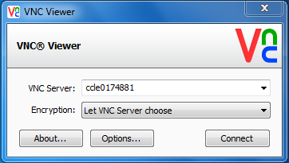

- From the Control Panel>System and Security>Administrative Tools; open the Task Scheduler

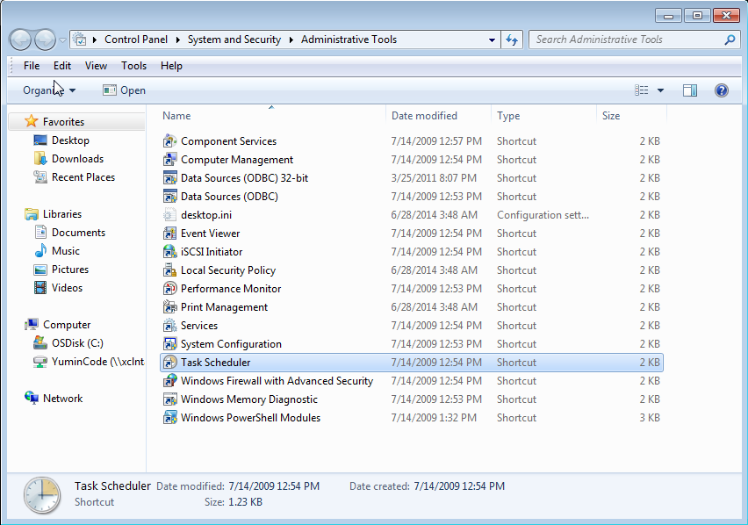

Initial Status of the Application under Maintenance

Modules/Interfaces/Data structures
Before beginning the maintenance activities, briefly describe each item covered under scope (above) and their current status. Identify if there are any defects and if so, has the Customer prioritized them.

Documents
List the documents supplied by the customer for carrying out the maintenance activity e.g. design documents, build procedures, installation manual etc,.

Standards and Guidelines
List the programming standards, guidelines, product standards etc,. which are applicable to support the application. These could be supplied by the Customer or decided by Wipro with <CLIENT>'s consent.

Application Environment

Development Environment |  | Test Environment
Identify the Application Development Environment (h/w, s/w) with the version numbers. |  | Identify the Application Test Environment (h/w, s/w) for integration and/or system testing with the version numbers.
Staging Environment (optional) |  | Production Environment
Identify the Application Staging Environment (h/w, s/w), if applicable, before deloying the application for production. |  | Identify the Application Production Environment (h/w, s/w) where this application will be deployed.

Affected Systems/Applications
List all systems and applications (including databases) that can be affected by or have a dependency on the application. The application's interface agreements, if any, should also be looked into. The persons responsible for the affected system(s) should be notified in advance of the change, if change affects the respective system in any manner.
.
Affected System / Application | Responsibility  (Wipro/<CLIENT>/Other) | Contact Details

User Interfaces
Describe the user interfaces / screens through which the user interacts with the application. Details of validations performed for each field on the screen should also be given. It is advisable to focus on critical fields for application with 30+ screens

Application Design

Relation to External Systems
Relationship of the application to the external systems/applications should be specified in terms of inputs/outputs. Pictorial representation may be used for clarity.

System / Sub-system Architecture
The overall system and sub-system architecture should be specified pictorially. The decomposition of the application into modules (or functions) and brief description of modules should be stated.

Inter-module Relationships
Interfaces, dependencies & relationships among modules should be explained. Data Flow Diagrams may be used here.

Application Modules
The following should be described for each module.

Module Name and Description
Brief description of the module should be provided.

Design Details
Please give a reference to the detailed design document.

Global Data Structure References
The Global Data structures and/or functions referred and modified by this module should be stated. This may be a subset of the entire set of global structures/functions defined for the application.

Module Specific Data Structures
The data structures defined & used within the module should be stated.

Database Details
Include the details pertaining to the database(s) in the application. This would typically include database design related details like ER Diagrams, Data Dictionary, etc., and database access information like, the different users, etc. In addition to this, if there are any specific activities that are carried out for the database administration, then details of such activities are also captured.

Batch Job Details
(This section gives the details of Batch jobs which are scheduled in the scheduler)

Daily Batch jobs
(This gives the daily batch flow diagram and the critical jobs and their primary purpose, predecessor and successor, restart information)

Weekly Batch jobs
(This gives the weekly batch flow diagram and the critical jobs and their primary purpose, predecessor and successor, restart information)

Monthly Batch jobs
(This gives the monthly batch flow diagram and the critical jobs and their primary purpose, predecessor and successor, restart information)

Quarterly Batch jobs
(This gives the quarterly batch flow diagram and the critical jobs and their primary purpose, predecessor and successor, restart information)

Global Data Structures and Shared Data Functions
The details of Global Data Structures used by all modules should be specified. All macros / prototypes / functions common to a set of applicatiions should be described.

Critical Functions
Functions that are critical to the functioning of modules should be identified. Additionally, functions that require extra focus while testing should be identified.Functions and modules that require 100% code reviews should be identified

Testing Strategies
Detail the testing strategies that are currently being used for the different types of testing

Test Data
Specify the initial status of test data supplied by the Customer, version no. and where it is located.

SLAs & Service Patch Deployment

Configuration Management
(This lists the libraries used by the application in various regions including development, QV and production regions to store the programs, jobs and reports)

Service Level Agreements (SLAs)
(This lists the application owners, SLAs, when does the system have to be up (application availability requirement), batches processed, how tight is the window now etc)

Maintenance and Service Patch Deployment Process
(This outlines How/when/why patches will be deployed and who will be involved)

Emergency fix Management
(This captures the current process followed when there is any emergency fix situation in production environment)

Reusable components

Limitations
Describe the limitations of this design like performance, scalability, portability, platform specific dependencies, memory constraintsetc.

Business continuity & Disaster recovery plan
(This section outlines information on the 'vital records’ (documents needed for the continuation of operations in the event of an outage to the application) produced or needed by the application)

Disaster Recovery Process
(This sub-section outlines the disaster recovery process currently followed for application. The Disaster recovery solutions followed and the recovery strategies used)

Vital Records
(This sub-section lists all the vital records produced and needed by the application)

References

BCP development toolkit

References
Provide a list of documents that have been referenced for preparing the ARM.

Application History

Typical Problems
Specify the problems typically encountered so far with the application such as updating specific data, interfacing with another application, hardware compatibility, missing screens, performance related problems etc.

Release History
Refer to the folder/ database location where application's release history/maintenance records are stored.. Look at release history of past one year to begin with

17. Learning
Update the SMTD document on a continuous basis capturing all the learning from this application

